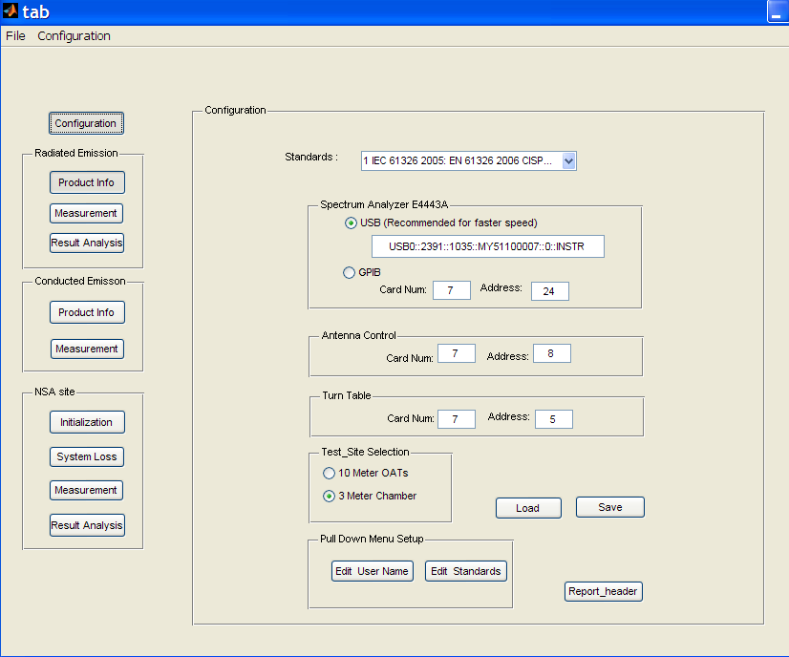

1. Select standard

The standards can be defined by “Edit Standards ” button. The program will load the file StandardName.txt automatically.

1. Edit User Name button
2. Setup measurement

When the program starts, it automatically load setup parameter from configuration.ini

* 1. Select test site
  2. Turn table GPIB
  3. Antenna GPIB
  4. SA GPIB or USB

Those info would be saved into configuration.ini

1. Setup Report Header

Save all header information into Report_header.txt, those info will be saved into test report in header format.

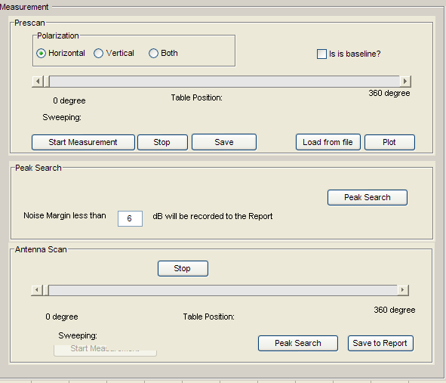

There are two ways to load the following variables

Result H

Result V

Result H_Baseline

Result H_Baseline

Either by measurement or by loading file from the previous measurement.

Case a. Measurement

The result would be array of selected band.

The band selection is

Band1- band 5 , 200MHz each zone 401 points

Band 6: 30MHz-1GHz zone 2001 points

It would save in array for example

ResultH(1).

|  |  |
| --- | --- |
| Freq | 1x2001 |
| Position | 1x35 |
| REValue | 2001x35 |
| Polarization | 0 |

PeakTable

PeakValue

tb_Position 1x1

tw_Position 1xn

Freq 1x1

REValue 2001xn

When the program starts,

Result H

Result V

Result H_Baseline

Result H_Baseline

Are empty. User can take measurement or load from files.

PeakTable

[%1 No. 2freq, 3 maxium measuremed value at fix height(changing table), 4 table angle. 5 limit 6 delt, 7 antenna height,8 maximum value at scanned height]

1. Click Peak search auto to preselect the peak list for scanning
2. Use “Manual “ to edit the peak list. Must use after the PeakSearch Auto is clicked. Change the 1x6 matrix to 1x8 matrix.
3. Must use load function to make the change.